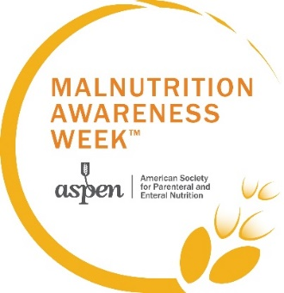

Sample Email Copy

SUBJECT LINE OPTIONS:
- Free access to malnutrition-related CE webinars and resources
- Free registration for CE webinars on treating malnutrition
- Malnutrition Awareness Week is September 8-12!

We are proud to announce that [Your organization] has partnered with ASPEN, the American Society for Parenteral and Enteral Nutrition, for ASPEN Malnutrition Awareness WeekTM (MAW) from September 8 to 12, 2025.
As ambassadors, we have complimentary access to ASPEN’s MAW webinars and resources.
Most of the webinars offer continuing education credits but space is limited, so register now to reserve your spot. Enter the code [ambassador code] at checkout to receive a 100% discount. Here are instructions on registering for the webinars and claiming CE credit.
Please also check out ASPEN’s Malnutrition Solution Center where there are practice tools, videos, podcasts, and papers for clinicians, as well as resources for patients.
Malnutrition Awareness Week aims to educate healthcare professionals on the early detection, prevention, and treatment of malnutrition and to encourage consumers to discuss their nutrition status with healthcare providers. For more information, visit nutritioncare.org/MAW.
Please use the hashtag #ASPENMAW25 on social media to raise awareness of nutrition’s crucial role in patient recovery. Many prepared images are available here.
*ASPEN is accredited to provide medical, pharmacy, nursing, and dietetic credits.

AMBASSADOR ORGANIZATIONS
As an ambassador, your members can attend our Malnutrition Awareness Week webinars for free! Be sure to include the unique code ASPEN has provided you in your member communications.

Details for Online Calendar/Newsletter/Blog
Malnutrition Awareness WeekTM
Date: September 8-12, 2025
Website: https://www.nutritioncare.org/maw
Contact Information: (301) 587-6315, aspen@nutritioncare.org
[Your organization] has partnered with ASPEN, the American Society for Parenteral and Enteral Nutrition, for ASPEN Malnutrition Awareness WeekTM (MAW) on September 8-12, 2025.
As an ambassador, we have complimentary access to ASPEN’s MAW webinars and resources.
Most of the webinars offer continuing education credits. Space is limited, so register now to reserve your spot. Enter code [ambassador code] at checkout to receive a 100% discount. Here are instructions on registering for the webinars and claiming CE credit.
Please use the hashtag #ASPENMAW25 on social media to raise awareness of nutrition’s crucial role in patient recovery. Many prepared images are available here.
*ASPEN is accredited to provide medical, pharmacy, nursing, and dietetic credits.

